EX No:1 | EDA-Data Cleaning
Aim:

Algorithm:

Program:
import pandas as pd
from sklearn.model_selection import train_test_split
from sklearn.impute import SimpleImputer
from sklearn.preprocessing import LabelEncoder, StandardScaler
from sklearn.tree import DecisionTreeClassifier
from sklearn.metrics import accuracy_score

# Direct path to your dataset file
file_path = r"C:\Users\AI_LAB\Downloads\archive\senate_stock_discosures.csv"

# Load dataset
df = pd.read_csv(file_path)

# ======================================================
# PART 1: Initial Data Cleaning & Basic Exploration
# ======================================================

# Remove duplicate rows[cite: 1]
df = df.drop_duplicates()

# Remove leading/trailing whitespaces from text columns[cite: 1]
for col in df.select_dtypes(include='object').columns:
df[col] = df[col].astype(str).str.strip()

# Fill missing values (Mean for numerical, Mode for categorical)[cite: 1]
for col in df.select_dtypes(include='number').columns:
df[col] = df[col].fillna(df[col].mean())

for col in df.select_dtypes(include='object').columns:
if not df[col].mode().empty:
df[col] = df[col].fillna(df[col].mode()[0])

print("\n===== Cleaned (Crisp) Dataset =====")
print(df)

print("\n===== First 10 Rows =====")
print(df.head(10))

print("\n===== Dataset Info =====")
print(df.info())

print("\n===== Dataset Summary Statistics =====")
print(df.describe(include='all'))

# ======================================================
# PART 2: KDD / SEMMA Pipeline Execution
# ======================================================

# 1. Sample (Shuffle dataset)[cite: 1]
df_sample = df.sample(frac=1, random_state=42).copy()

# 2. Explore[cite: 1]
print("\n===== Sampled Data Info =====")
print(df_sample.info())
print(df_sample.describe(include='all'))

# 3. Modify (Clean & Preprocess)[cite: 1]
for col in df_sample.select_dtypes(include='number').columns:
df_sample[col] = SimpleImputer(strategy='mean').fit_transform(df_sample[[col]])

for col in df_sample.select_dtypes(include='object').columns:
df_sample[col] = SimpleImputer(strategy='most_frequent').fit_transform(df_sample[[col]]).ravel()

# Encode categorical variables[cite: 1]
for col in df_sample.select_dtypes(include='object').columns:
df_sample[col] = LabelEncoder().fit_transform(df_sample[col])

# Feature / Target Separation
# Targets the transaction type column if present, otherwise defaults to the last column[cite: 1]
if 'type' in df_sample.columns:
X = df_sample.drop(columns=['type'])
y = df_sample['type']
elif 'transaction' in df_sample.columns:
X = df_sample.drop(columns=['transaction'])
y = df_sample['transaction']
else:
X = df_sample.iloc[:, :-1]
y = df_sample.iloc[:, -1]

# Feature Scaling[cite: 1]
scaler = StandardScaler()
X_scaled = scaler.fit_transform(X)

# Train/Test Split[cite: 1]
X_train, X_test, y_train, y_test = train_test_split(
X_scaled, y, test_size=0.2, random_state=42
)

# 4. Model (Decision Tree Classifier)[cite: 1]
model = DecisionTreeClassifier(random_state=42)
model.fit(X_train, y_train)

# 5. Assess[cite: 1]
predictions = model.predict(X_test)
accuracy = accuracy_score(y_test, predictions)

print(f"\nModel Accuracy: {accuracy:.2%}")
Output:

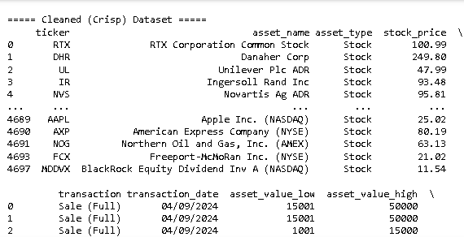
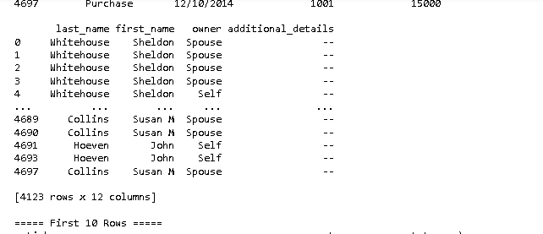
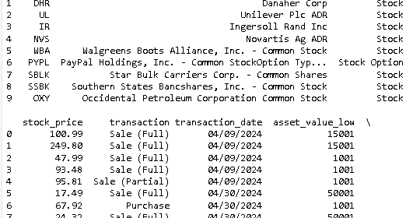

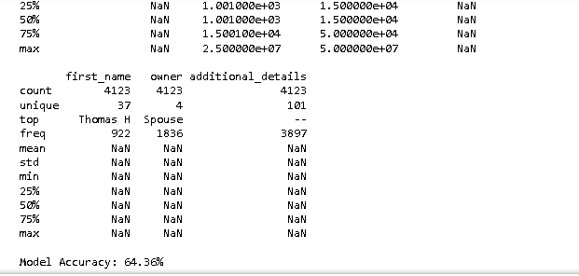

Result:

